Is the hero a human?

/ \

Is it an ape? Is the hero male?

/ \ / \

Wrecking ball Winston Can she fly? Is he a healer?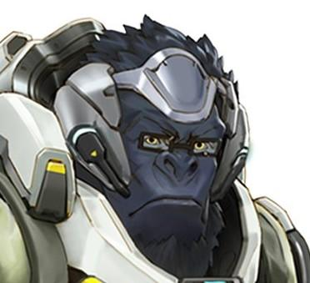

/ \ / \

Is she a healer? Sombra Lucio Reaper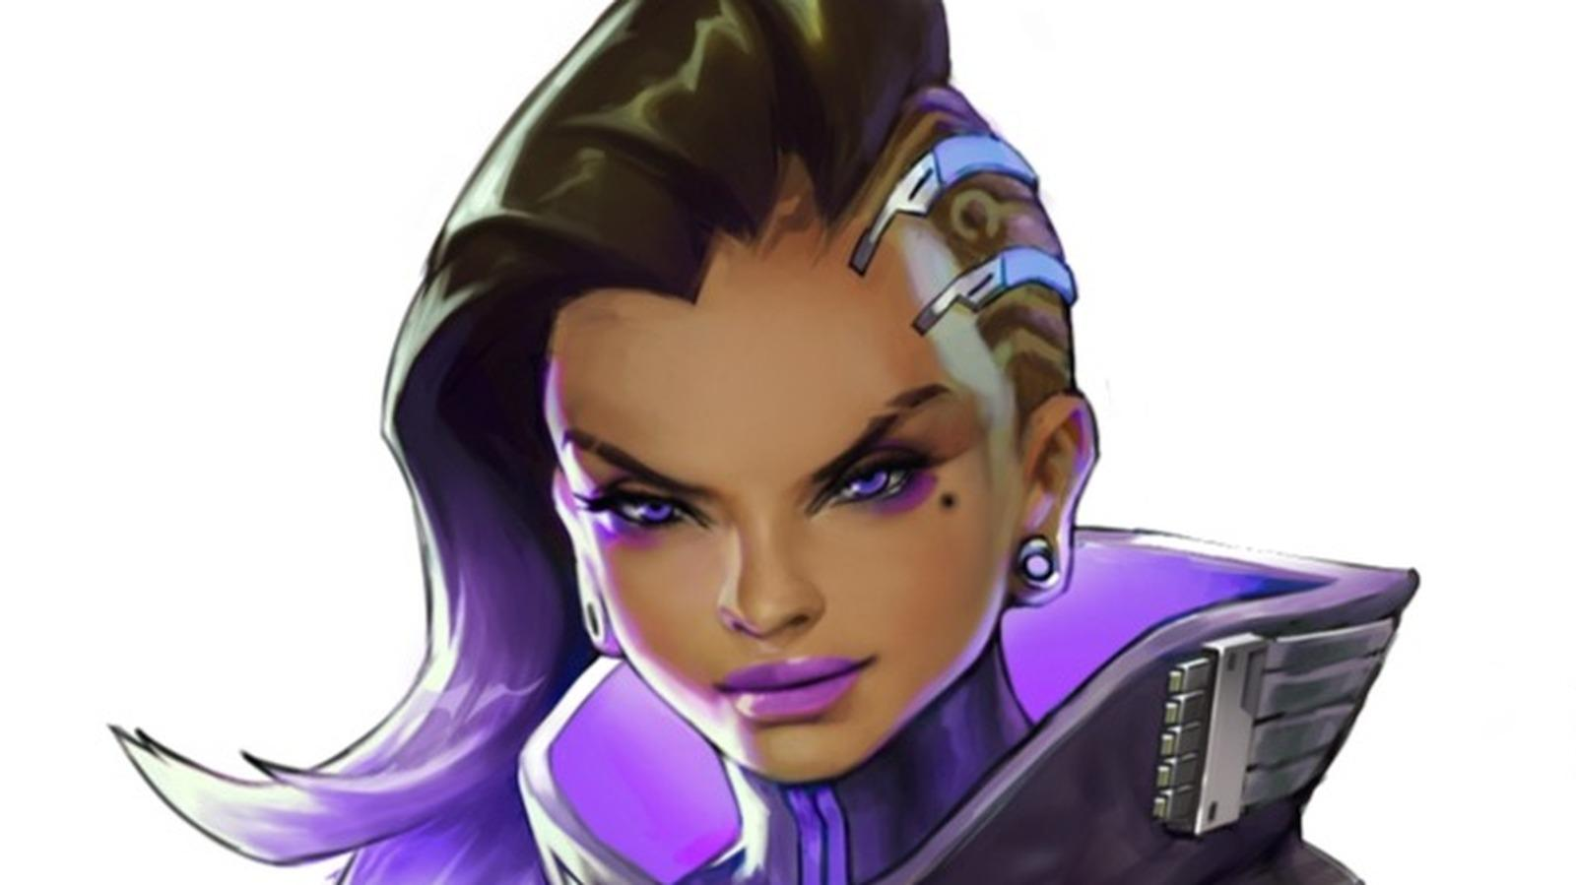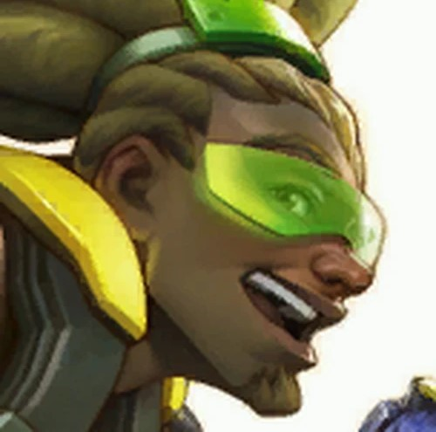

/ \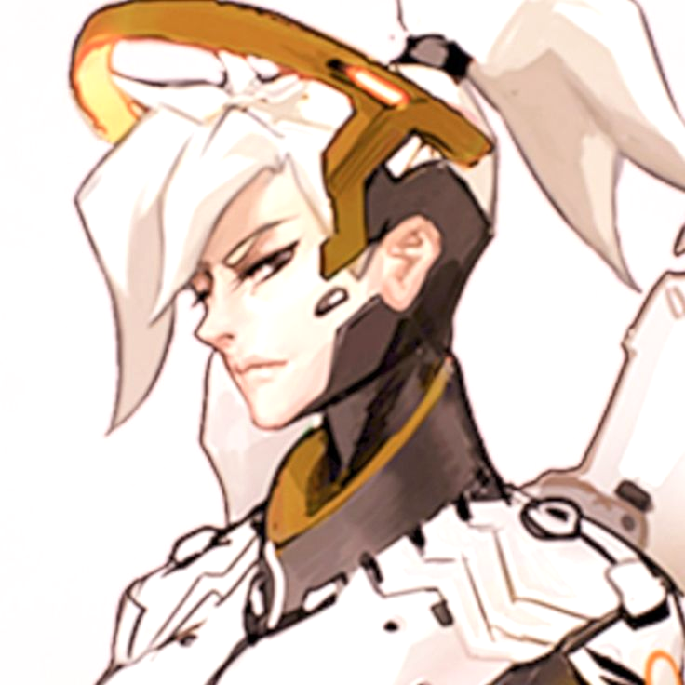

Overwatch is a first person hero based shooter with a diverse cast of characters.

Type “hero_finder.” to begin.